ASR 7093

**From:** Kio, Xi Xiang   
**Sent:** Wednesday, 25 April, 2018 11:14 AM  
**To:** Chan, Pei-Fong  
**Cc:** Jack, Fong; Rahamat, Mohd Syaiful Adli; Tat Shin Vun  
**Subject:** RE: New labeling content for Hypoint product (India Labeling)

Hi Pei Fong,

Need some amendments to the work order, please find attached for the comments.

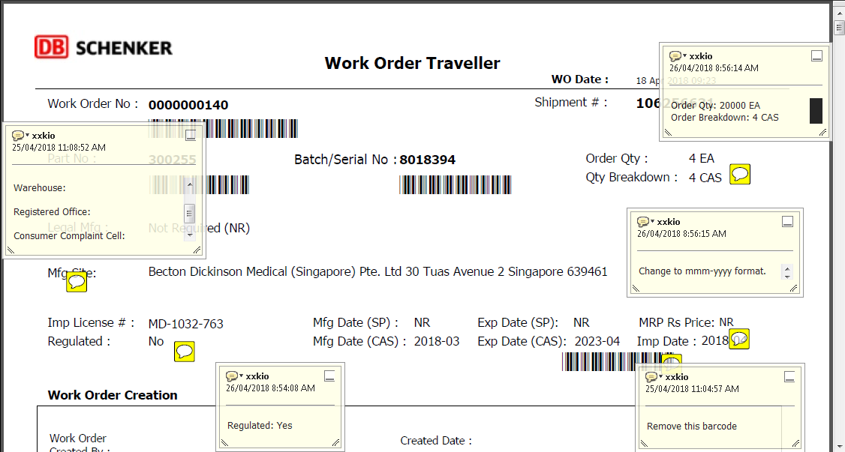

|  |  |  |
| --- | --- | --- |
| No | Request Changes | Remarks |
| 1 | Order Qty: 20000 EA  Order Breakdown: 4 CAS | Fixed. |
| 2 | To add new rows  Imported and Distributed by:  Warehouse:  Registered Office:  Consumer Complaint Cell: |  |
| 3 | Regulated: Yes | Regulated setting in master -> “SKU Work order” setup – Regulated = YES |
| 4 | Change to mmm-yyyy format.  Eg: Apr 2018 | Fixed |
| 5 | Remove barcode | Fixed. |

3. SKU Work order setup – Regulated = YES

